**Data Science Questions and Answers – Introduction to Regression Models**

**This set of Data Science Multiple Choice Questions & Answers (MCQs) focuses on “Introduction to Regression Models”.**

1. Which of the following function can be replaced with the question mark in the below figure ?  
[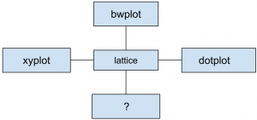](https://www.sanfoundry.com/wp-content/uploads/2015/10/data-science-questions-answers-introduction-regression-models-q1.png)  
a) boxplot  
b) lplot  
**c) levelplot**  
d) all of the Mentioned  
View Answer

2. Point out the correct statement:  
a) The mean is a measure of central tendency of the data  
b) Empirical mean is related to “centering” the random variables  
c) The empirical standard deviation is a measure of spread  
**d) All of the Mentioned**  
View Answer

3. Which of the following implies no relationship with respect to correlation ?  
a) Cor(X, Y) = 1  
**b) Cor(X, Y) = 0**  
c) Cor(X, Y) = 2  
d) All of the Mentioned  
View Answer

4. Normalized data are centered at ___ and have units equal to standard deviations of the original data.  
**a) 0**  
b) 5  
c) 1  
d) 10  
View Answer

5. Point out the wrong statement:  
a) Regression through the origin yields an equivalent slope if you center the data first  
b) Normalizing variables results in the slope being the correlation  
**c) Least squares is not an estimation tool**d) None of the Mentioned  
View Answer

6. Which of the following is correct with respect to residuals ?  
**a) Positive residuals are above the line, negative residuals are below**b) Positive residuals are below the line, negative residuals are above  
c) Positive residuals and negative residuals are below the line  
d) All of the Mentioned  
View Answer

7. Minimizing the likelihood is the same as maximizing -2 log likelihood.  
**a) True**  
b) False  
View Answer

8. Which of the following refers to the circumstance in which the variability of a variable is unequal across the range of values of a second variable that predicts it ?  
a) Heterogenity  
**b) Heteroskedasticity**  
c) Heteroelasticty  
d) None of the Mentioned  
View Answer

9. Which of the following outcome is odd man out in the below figure ?  
[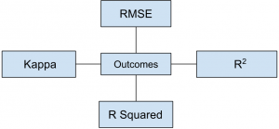](https://www.sanfoundry.com/wp-content/uploads/2015/10/data-science-questions-answers-introduction-regression-models-q9.png)  
a) R Squared  
**b) Kappa**  
c) RMSE  
d) All of the Mentioned  
View Answer

10. Residuals are useful for investigating best model fit.  
a) True  
**b) False**  
View Answer